Whippet Coursing Champ – Belle – Tish Curran
Reserve – Berry – Lisa Rule
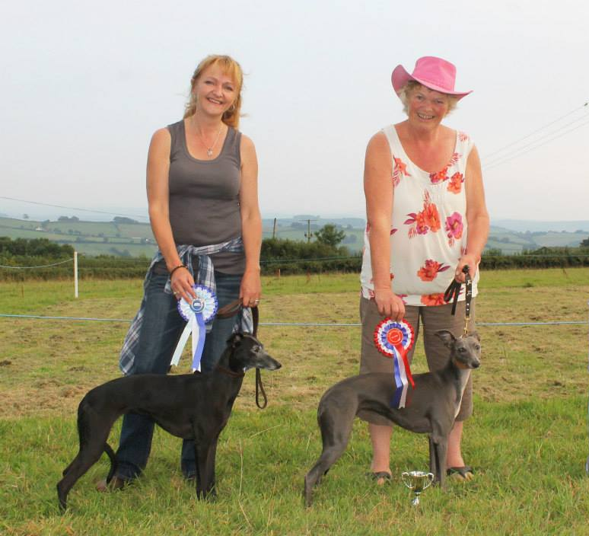
Under 23” Coursing Champ – EB – Shane Hill
Reserve – Sika – Tish Curran
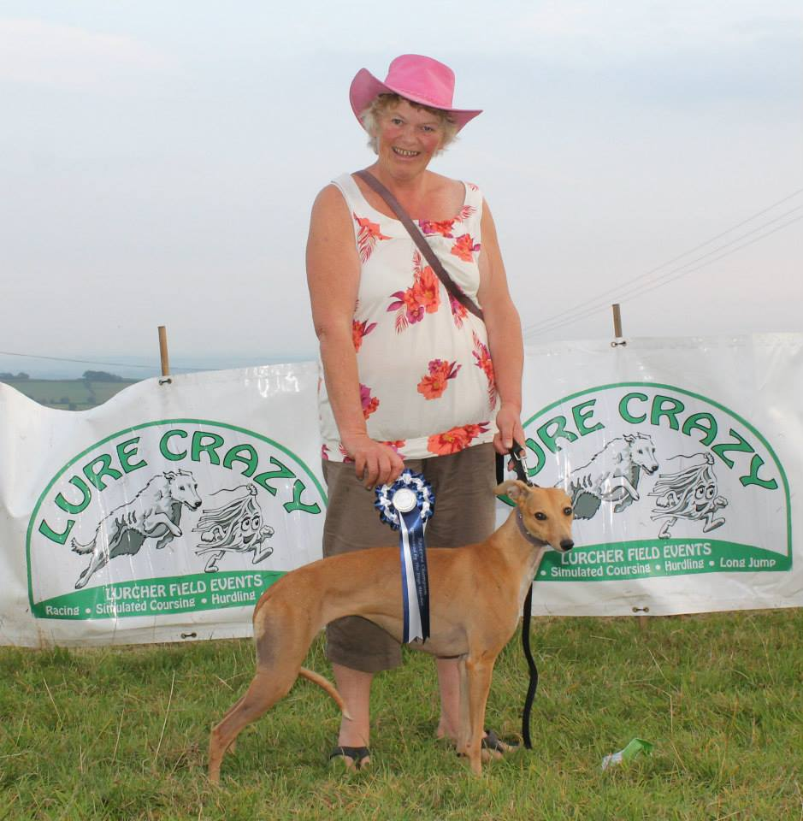
Over 23” Coursing Champ – Kea – Kev Mumford
Reserve – Sark – Jo Hicks
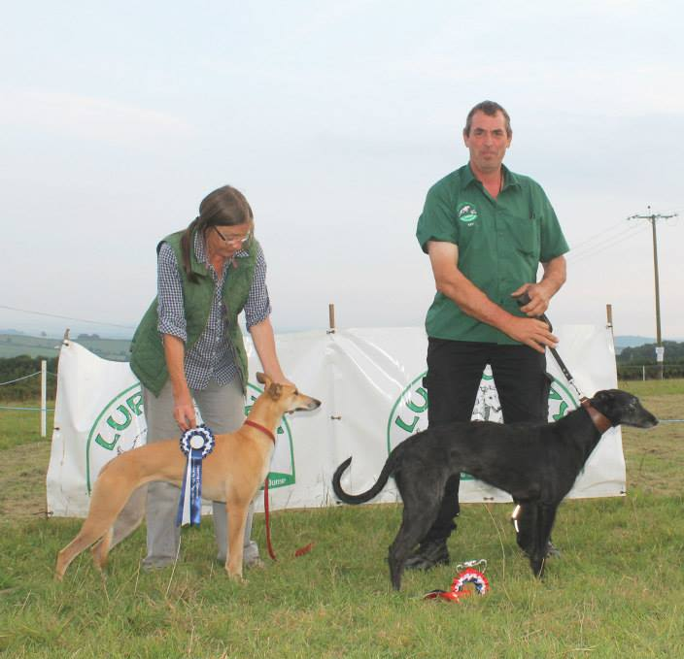
Terrier Hurdles Champ – Lola – Tish Curran
Reserve – Bert – Robert Brownchurch
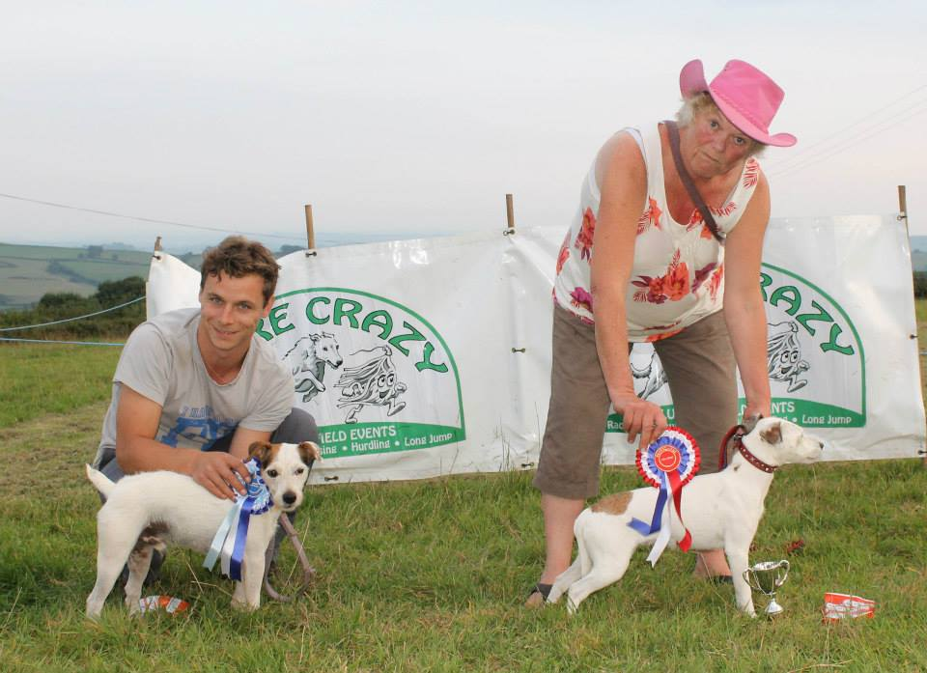
Whippet Hurdles Champ – Tea Leaf – Catriona Ryan
Reserve – Fallow – Tish Curran
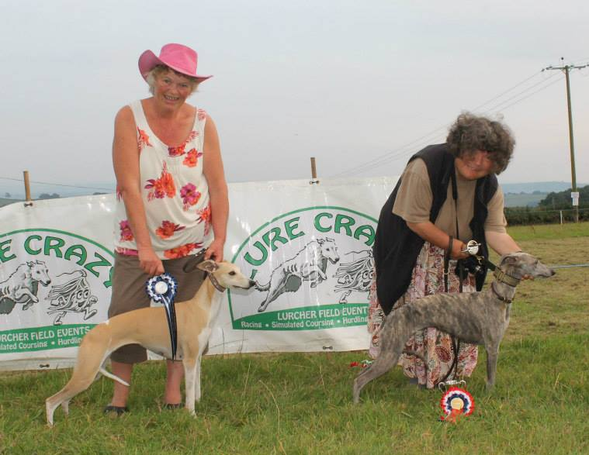
Under 23” Hurdles Champ – Alfie – Paul Studdy
Reserve – Star – Frank Bayley
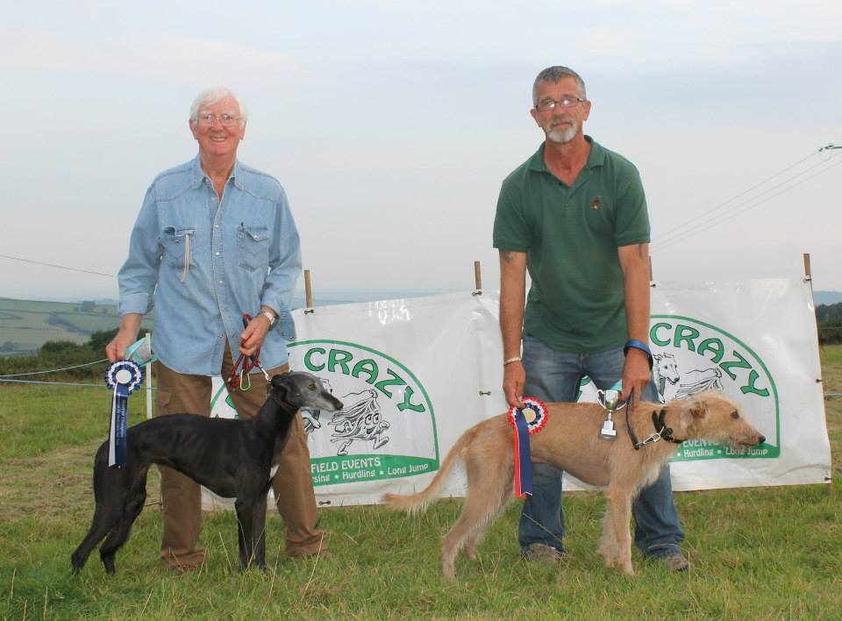

Over 23” Hurdles Champ – Libby – Lisa Rule
Reserve – Indie – Burnie and Yvonne Rogerson
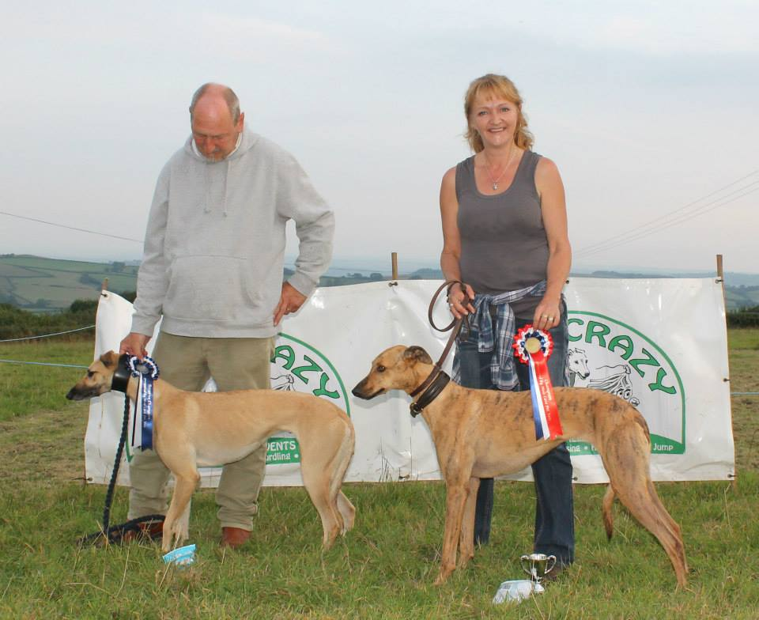
Terrier Straights Champ – Fred – Matt Wyld & Carly Skelton
Reserve –Ness Pit – Tish Curran
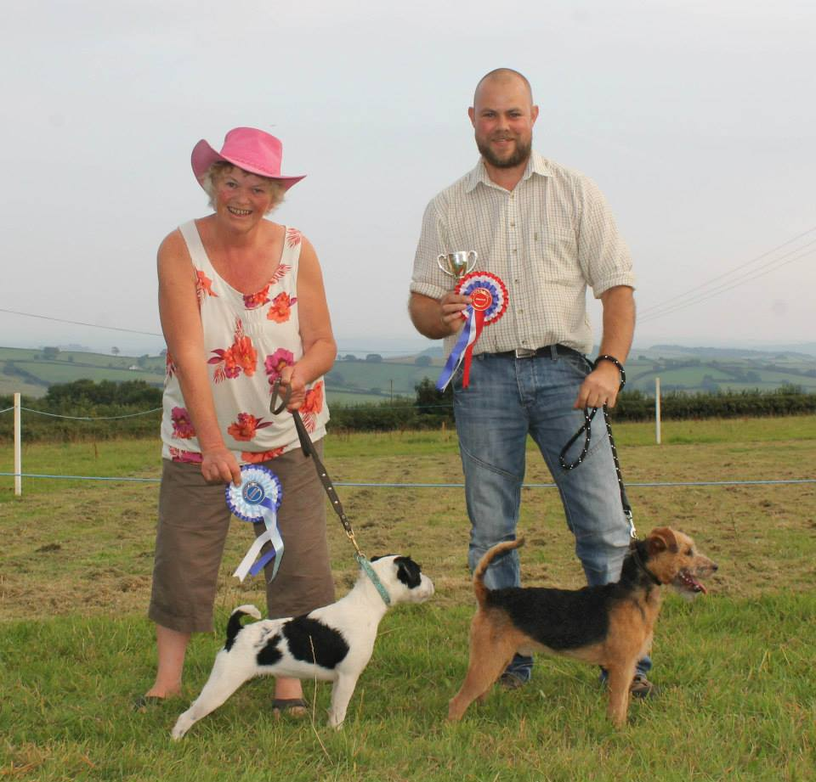
Whippet Straights Champ –Tea Leaf – Catriona Ryan
Reserve – Joe – Lisa Rule
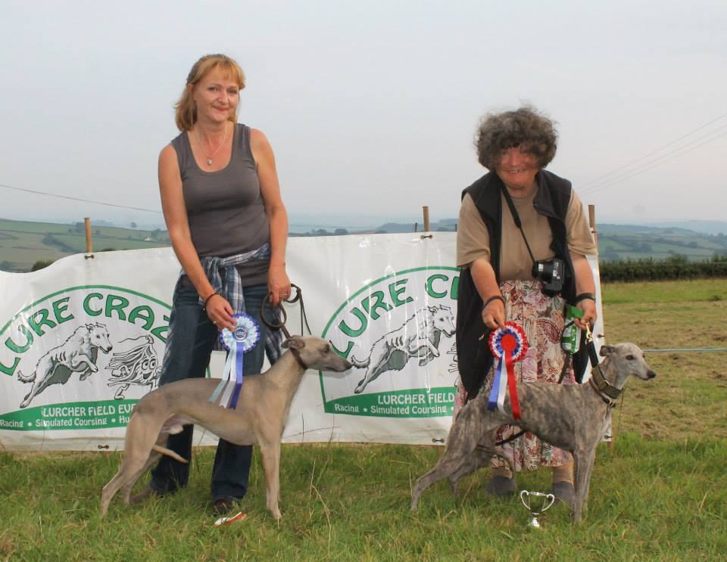
Under 23” Straights Champ – Robyn – Tish Curran
Reserve – Sika – Tish Curran
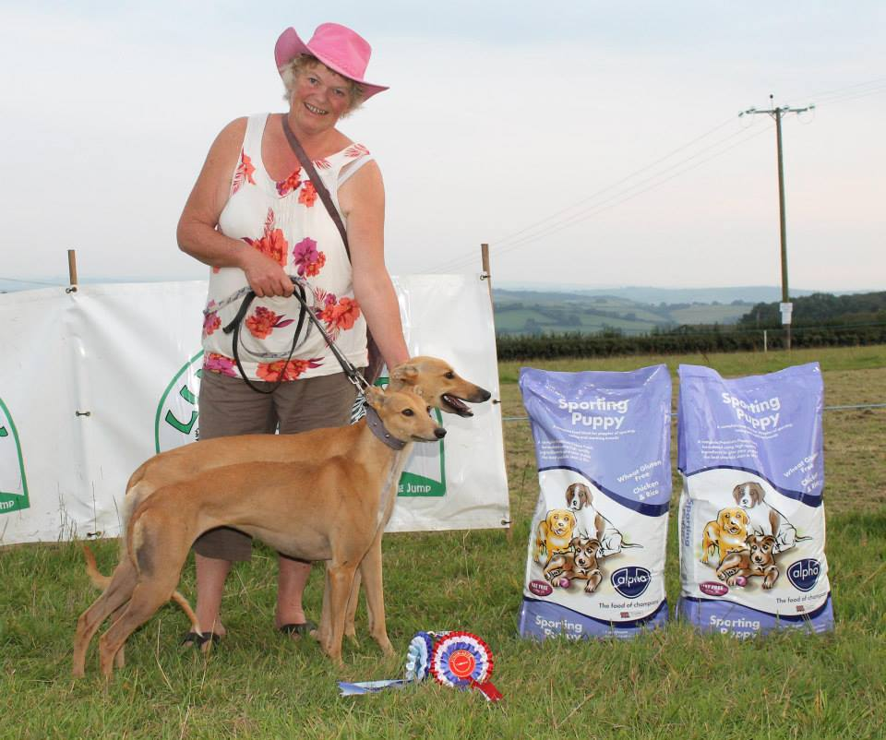
Over 23” Straights Champ – Midas – Jackie Cullum
Reserve – Blake – Joe Orcheston
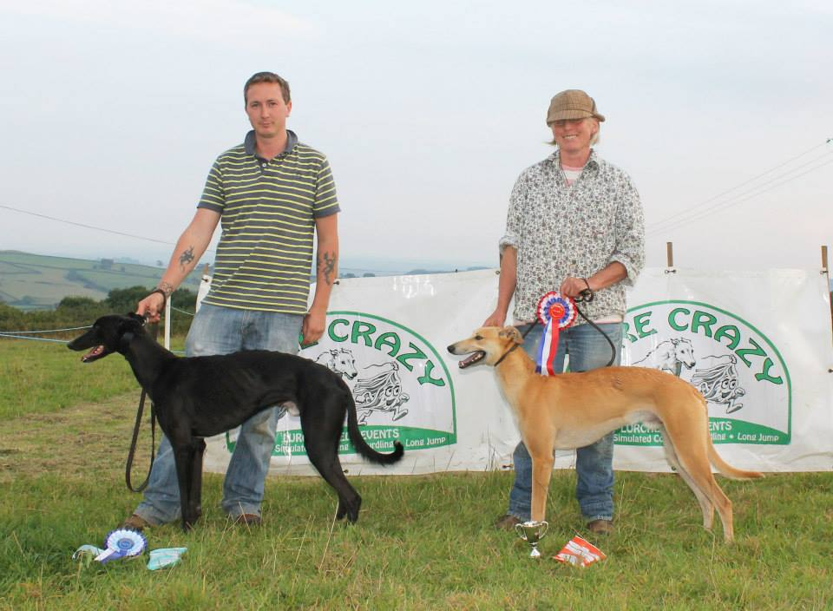
Lurcher Puppy Straights Champ – Fae – Chris Hill
Reserve – Murphy
