Stonelands Showing Results 30-09-18
Stonelands Bull X championship – 1st Ken Danes’ ‘Zinc’, 2nd Chris Searls’ ‘Dotty’, 3rd Kody Sherwood’s ‘Luna’, 4th ‘Lorrain Goss’’ ‘Moses’, 5th Kevin Stanley’s ‘Nyla’ 6th Jess Mitchells’ ‘Skittle’
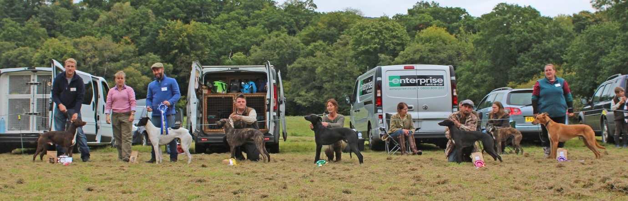

Stonelands Working Lurcher Championship – 1st Chris Hills ‘Fae’ 2nd Kevin Stanleys ‘Nyla’ 3rd Chris Hills ‘Red’ 4th Chris Hills ‘Ely’ 5th Caryl Harris’s ‘Gem’ 6th Glen Starlings ‘Cerys’

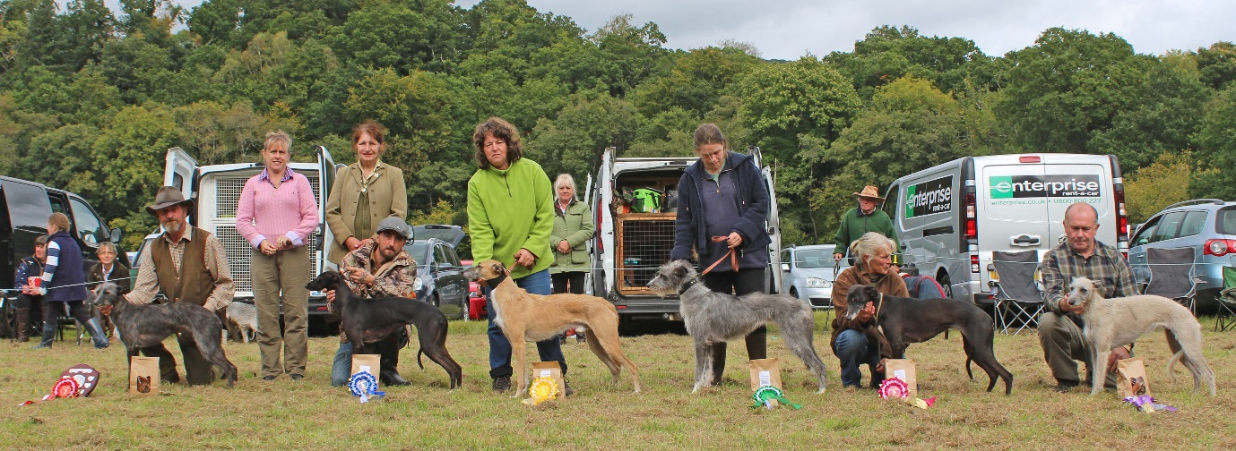

Stonelands Terrier Champ of Champs – 1st Terry Lethbridge’s ‘Sid, 2nd Tim Mitchell’s ‘Granit’ 3rd J Apps ‘Havock’ 4th Phil Goss’s ‘Cooper’
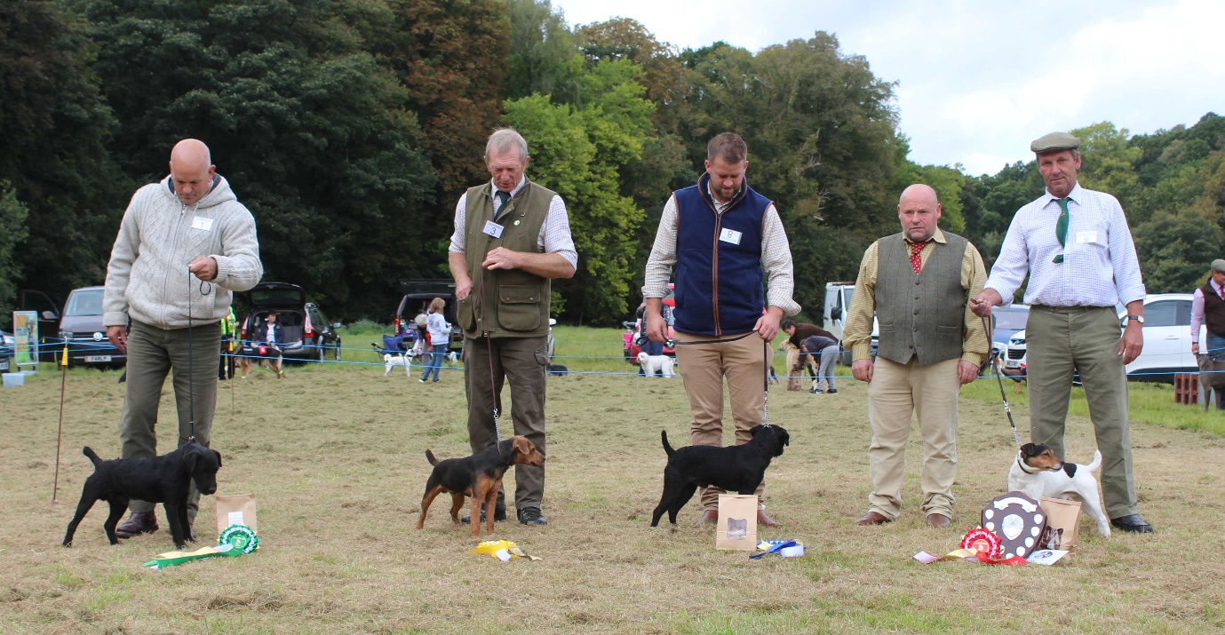

Stonelands Lurcher Champ of Champs – 1st Sarah Dobles ‘Sox’, 2nd Julie Tinsley’s ‘Kipper’, 3rd Ross Body’s ‘Reema’ 4th Lorrain Goss’s ‘Raven’
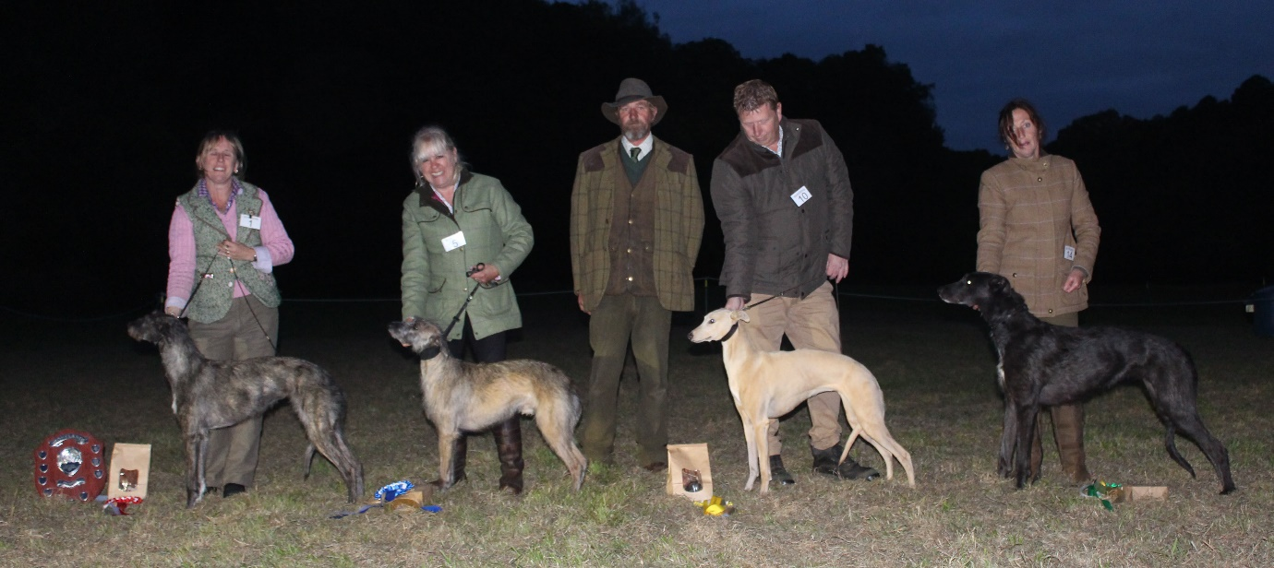

Stonelands U21” Lurcher Championship 1st Susanne Davey’s ‘Ziggy’, 2nd Chris Hills ‘Fae’ 3rd Sonia Doels ‘Marley’ 4th Caryl Harris’ ‘Lace’

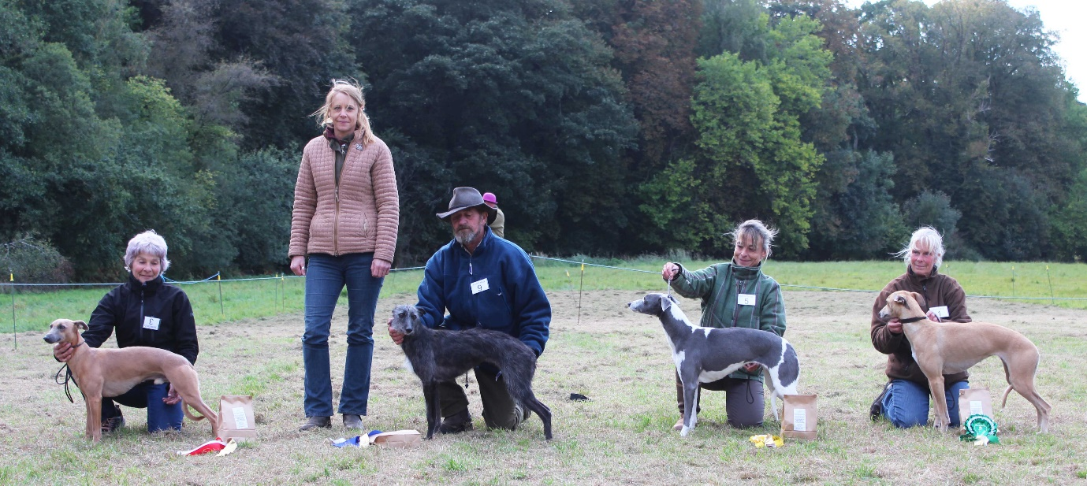
Stonelands Veteran Lurcher Championship 1st ‘Sarah Dobles ‘Zante’ 2nd Heather Wills ‘Haze’ 3rd Julie Tinsleys ‘Wilf’ 4th Karen Faints ‘Poppy’

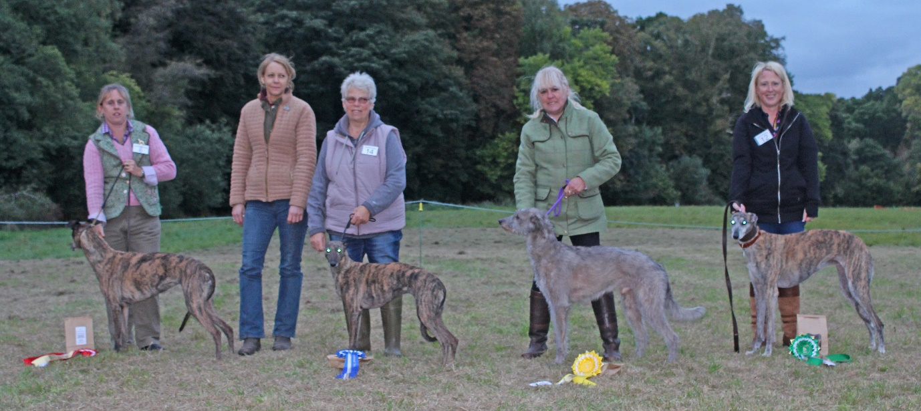

Open Show Results;
Lurcher Puppy Champion Sonia Doels ‘Orka’ Sue Neals’ Teddy reserve
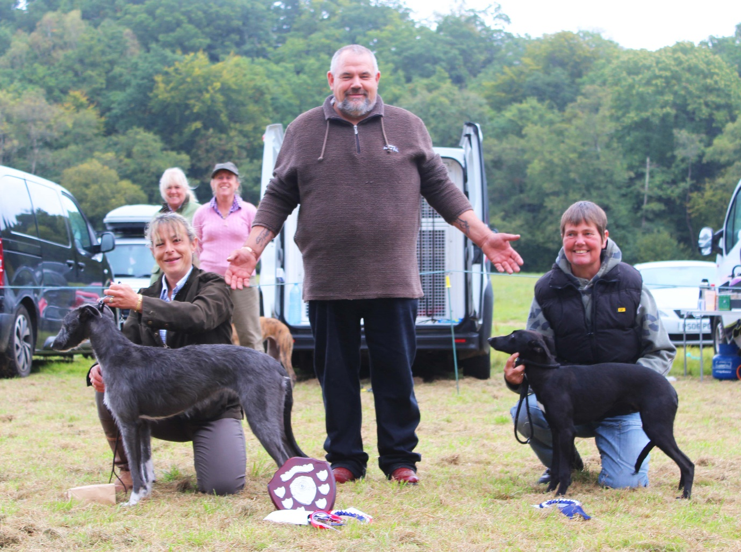

Unders Lurcher Champion Kevin Stanleys ‘Nyla’ Glen Starlings ‘Cerys’ reserve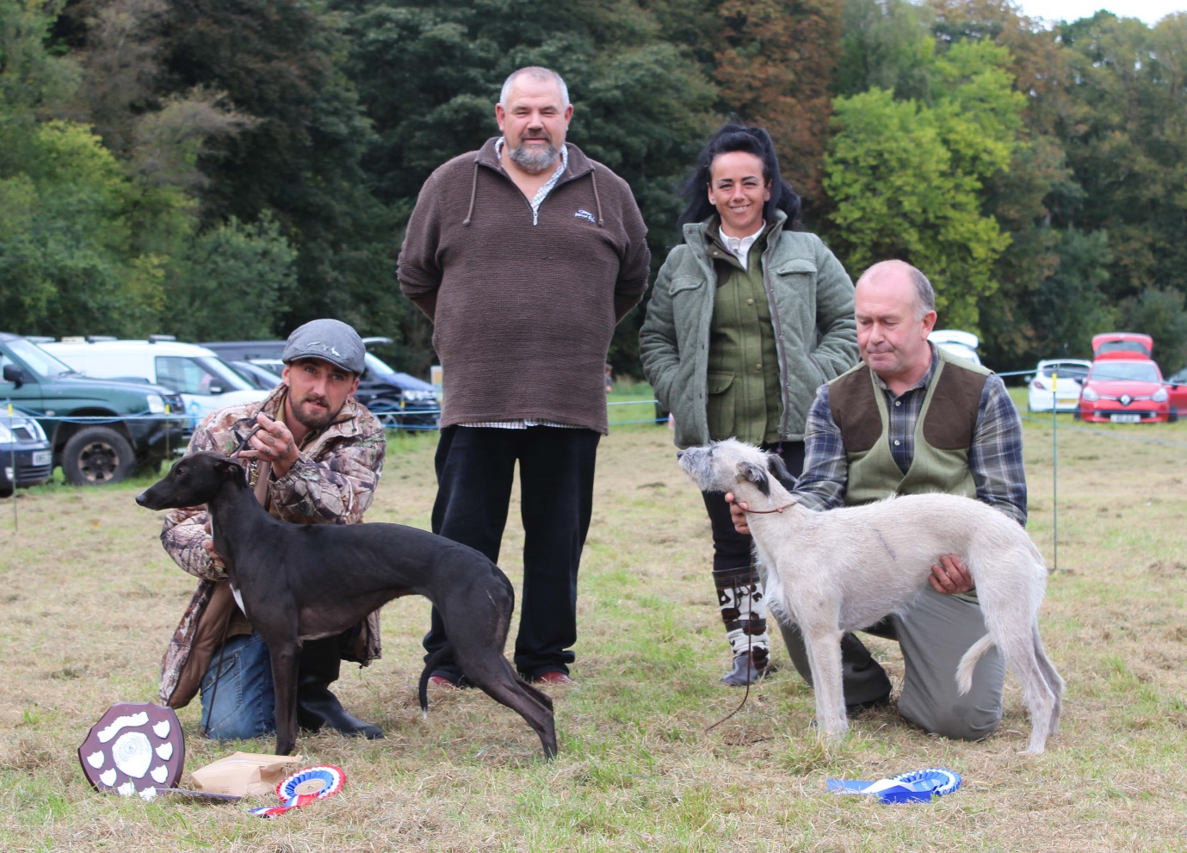

Overs Lurcher Champion Lisa Rules ‘Siren’ Lorrain Howes ‘Raven’ reserve
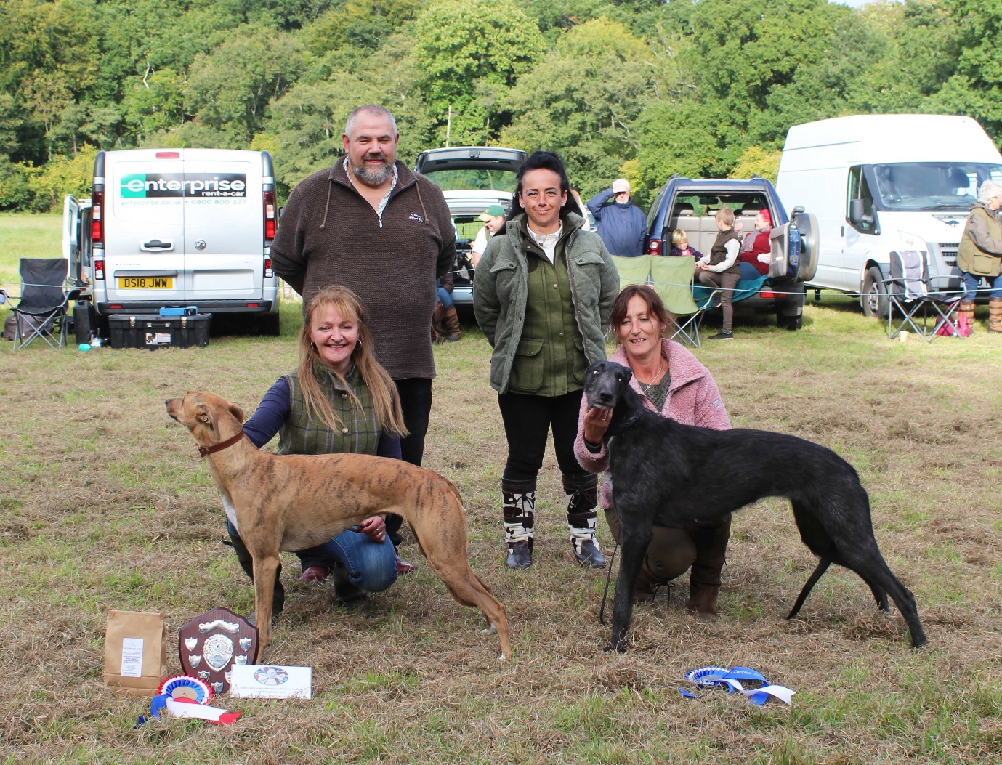

Supreme Lurcher Champion Siren and Nyla reserve supreme
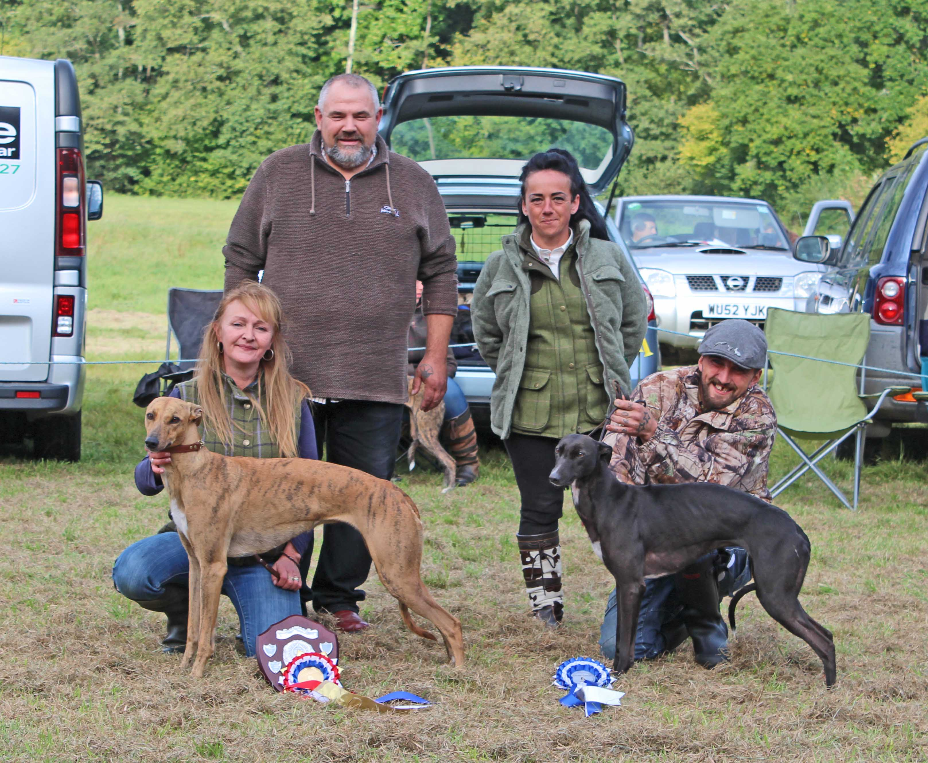

Whippet Puppy Champion J Manleys ‘Dexter’ J Needhams ‘Kevin’ reserve
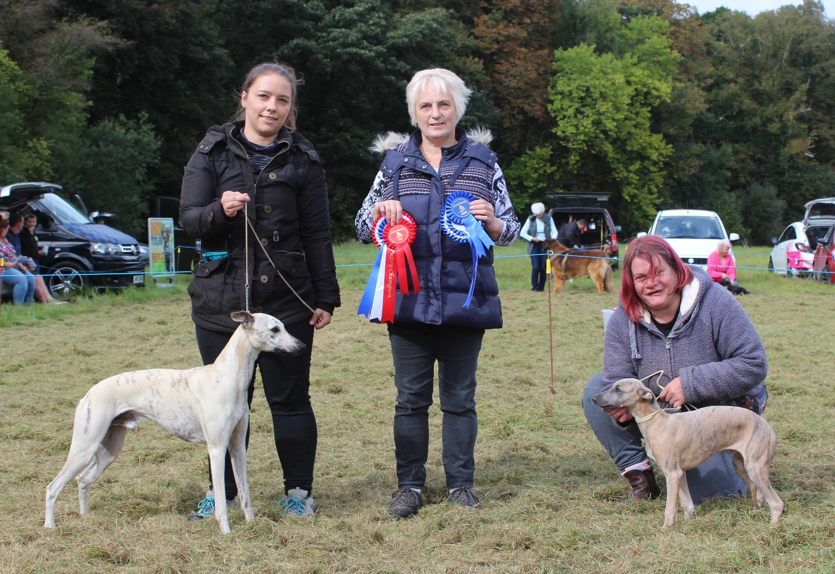
Whippet open show won by Sammie Hunts ‘Gracie’ J Needhams ‘Trevor’ reserve
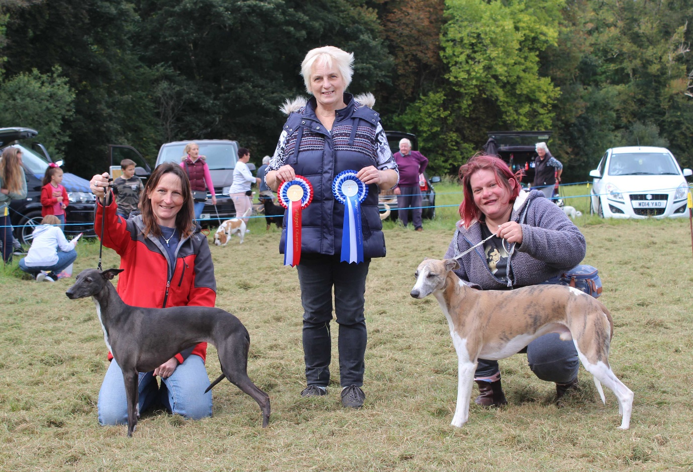

Terrier Puppy champion and reserve……
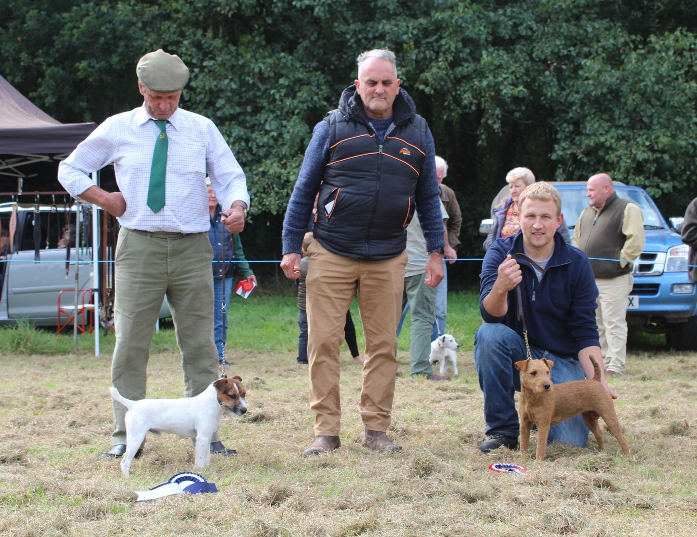
Terrier Champion J Apps ‘Hattie’ Mark Hills ‘Reg’